**TEAMDUTY Web-application**

Software Requirement Specification

**By**

Mr. Manuchet Manoi 542115049

Mr. Saknarong Noipaksa 542115061

Department of Software Engineering

College of Arts, Media and Technology

Chiang Mai University

**Project Advisor**

______________________________________

**Aj. Jayakrit Hirisajja**

**Document History**

|  |  |  |  |  |  |  |  |
| --- | --- | --- | --- | --- | --- | --- | --- |
| **Document Name** | **Version** | **Status** | **Date** | **Viewable** | **Reviewer** | | **Responsible** |
| **Documents** | | | | | | | |
| TEAMDUTY - Web application - SRS v 0.1.docx | **Add Chapter 1**  - Objective  - Intended Audience and Reading Suggestions  - Project Scope | Draft | 01 May 2014 | MM,  SN,JH | | MM,  SN | MM,  SN |
| TEAMDUTY - Web application - SRS v 0.1.docx | **Add Chapter 2**  **-** Product Perspective  - Product Features  - User Classes and Characteristics  - Operation Environment  - Design and Implementation Constraints  **Add Chapter 3**  **-**User requirement  **Add Chapter 5**  -Traceability Record | Draft | 01 May 2014 | MM,  SN,JH | | MM,  SN | MM,  SN |
| TEAMDUTY - Web application - SRS v 0.2.docx | **Adjust Chapter 3**  -Approve URS & SRS | Draft | 06 May 2014 | MM,  SN,JH | | MM,  SN | MM,  SN |
| TEAMDUTY - Web application - SRS v 0.3.docx | **Add Chapter 4**  -Software Requirement Specification  -Use case Description & Activity Diagram  -Quality Requirement | Draft | 08 May 2014 | MM,  SN,JH | | MM,  SN | MM,  SN |
| TEAMDUTY - Web application - SRS v 0.3.docx | **Adjust Chapter 4**  -Software Requirement Specification  -Use case Description & Activity Diagram  -Quality Requirement | Draft | 06 July2014 | MM,  SN,JH | | MM,  SN | MM,  SN |
| TEAMDUTY - Web application - SRS v 1.0.docx | **Adjust Chapter 4**  -Use case Description | Draft | 21 July2014 | MM,  SN,JH | | MM,  SN | MM,  SN |

**\*MM = Manuchet Manoi**

**\*SN = Saknarong Noipaksa**

**\*JH = Jayakrit Hirisajja**

**Table of Contents**

Chapter One | Introduction 4

1.1 Objective 4

1.2 Intended Audience and Reading Suggestions 4

1.2.1 Intended Audience 4

1.2.2 Reading Suggestions 4

1.3 Project Scope 5

Chapter Two | Overall Description 6

2.1 Product Perspective 6

2.2 User Classes and Characteristics 6

2.3 Operation Environment 7

2.4 Design and Implementation Constraints 7

Chapter Three | User Requirement 8

Chapter Four | System Feature 10

4.1 Software Requirement Specification 10

4.2 Use case Description & Activity Diagram 16

4.2.1 Use case Description and Activity Diagram 16

4.3 Quality Requirement 63

# Chapter One | Introduction

## Objective

The Objective of this (SRS) Software requirement specification is establish requirement for TEAMDUTY Web application and show all of description and specification of TEAMDUTY Web application. And this Software requirement specification is guidelines for develop software correctly and match with requirement.

## Intended Audience and Reading Suggestions

### 1.2.1 Intended Audience

***Development team***

* Software Requirement specification help Development team understand the scope of the project and detail of software before implementation.
* Software Requirement specification help development team develop program efficiently.
* Software Requirement specification help development team can check software product that match with requirement of program or not.

***User***

* Software requirement specification will help the user to know detail and description of software product.
* User can check that the requirements in software requirement specification match with their requirement or not.
* Software requirement specificationhelp user and development understand in program corresponding

### 1.2.2 Reading Suggestions

This software requirement specification will classify requirements by user into 3 type including **service request customer**, **Guest**, **freelance supply** and **Administrator**. And for each progress we will separated to send in each progress as followed;

|  |  |
| --- | --- |
| **Submit on-** | **User Requirement specification of-** |
| May | Feature 1 # Account Management System  Feature 2 # Service request customer management system. |
| July | Feature 3 # Search system  Feature 4 # Software-freelance supply management system  Feature 5 # Communication system |
| September | Feature 6 # Verification system  Feature 7 # Admistrator Management system |

## 1.3 Project Scope

The scope of this software requirement speciation is strategies to establish the system that:

* The Software System is Web-application.
* The Software System provide only software side.
* The Software System divide to two main part of user that is software human resource, and software job auction project.
* Show requirement and detail of Software system

TEAMDUTY – web application is a website application. This will provide a system to manage about software freelance finding job software human resource.

# Chapter Two | Overall Description

## 2.1 Product Perspective

TEAMDUTY – Web application to contract both of Software freelancer and Software employer. The application provides feature help Software freelancer to find software job. And help Software employer to find Software human resource in software project.

## 2.2 User Classes and Characteristics

There are 3 type of user, which interact to TEAMDUTY-web application system. That is **service request customer, freelance supply**, **Guest** and **Administrator** (this is only URS in feature 1)

**Guest**

E-URS – 01: The ***service request customer*** can be Register and select type of user as *service request customer*

E-URS – 02: The ***service request customer*** can be ConfirmRegister in their Email that they input on previously

E-URS – 09: The ***service request customer*** can view posted job list in system.

**Service request customer**

E-URS – 01: The ***service request customer*** can be Register and select type of user as *service request customer*

E-URS – 02: The ***service request customer*** can be ConfirmRegister in their Email that they input on previously

E-URS – 03: The ***service request customer*** can be Login to use Web Application after get user account.

E-URS – 04: The ***service request customer*** can manage to add or edit Picture, Name, Company name, Address, Introduce yourself, and Telephone number in profile detail as *service request customer*.

E-URS – 05: The***service request customer*** can be Logout from web application

E-URS – 06: The***service request customer*** can be ask their password form system if they forgot

E-URS – 07: The ***service request customer*** can post job and Detail as Project Name, Budget, Information, skill required and Software role categories to system that show to both of user as *service request customer* and *freelance supply*.

E-URS – 08: The ***service request customer*** can view Picture Name, Skill, and Address, Introduce yourself, Software role category, Fax and Telephone number in Profile detail of freelancer.

E-URS – 09: The ***service request customer*** can view posted job list in system.

E-URS – 10: The ***service request customer*** can view list of bidder in each project include budget & bidding detail

E-URS – 11: The ***service request customer*** can request freelancer that come to bidding their (***service request customer***) project

E-URS – 12:The ***service request customer*** can view confirm project message from freelancer

E-URS – 13: The ***service request customer*** can view list of project that available.

E-URS – 14: The ***service request customer*** can uploadfile in project management process

E-URS – 15: The ***service request customer*** can downloadfile in project management process

E-URS – 16: The ***service request customer*** can chat with each other in project management process

**Freelance supply**

F-URS – 01:The ***freelance supply*** can be Register and select type of user as *freelance supply*

F-URS – 02:The ***freelance supply*** can be ConfirmRegister in their Email that they input on previously

F-URS – 03: The***freelance supply*** can be Login to use Web Application after get user account.

F-URS – 04: The ***freelance supply*** can manage to Add or Edit Picture Name, Skill, Address, Introduce yourself, and Telephone number in Profile detail as *freelance supply*.

F-URS – 05: The***freelance supply*** can be Logout from web application

F-URS – 06: The***freelance supply*** can be ask their password form system if they forgot

F-URS – 07: The ***freelance supply***can request job input detail of biding and budget below project information

F-URS – 08: The ***freelance supply***can view list of notification-project that posted from The ***service request customer***

F-URS – 09: The ***freelance supply***can view list of project that available.

F-URS – 10: The ***freelance supply***can uploadfile in project management process

F-URS – 11: The ***freelance supply***can downloadfile in project management process

F-URS – 12: The ***freelance supply***can chat with each other in project management process

## 2.3 Operation Environment

**Notebook or PC**

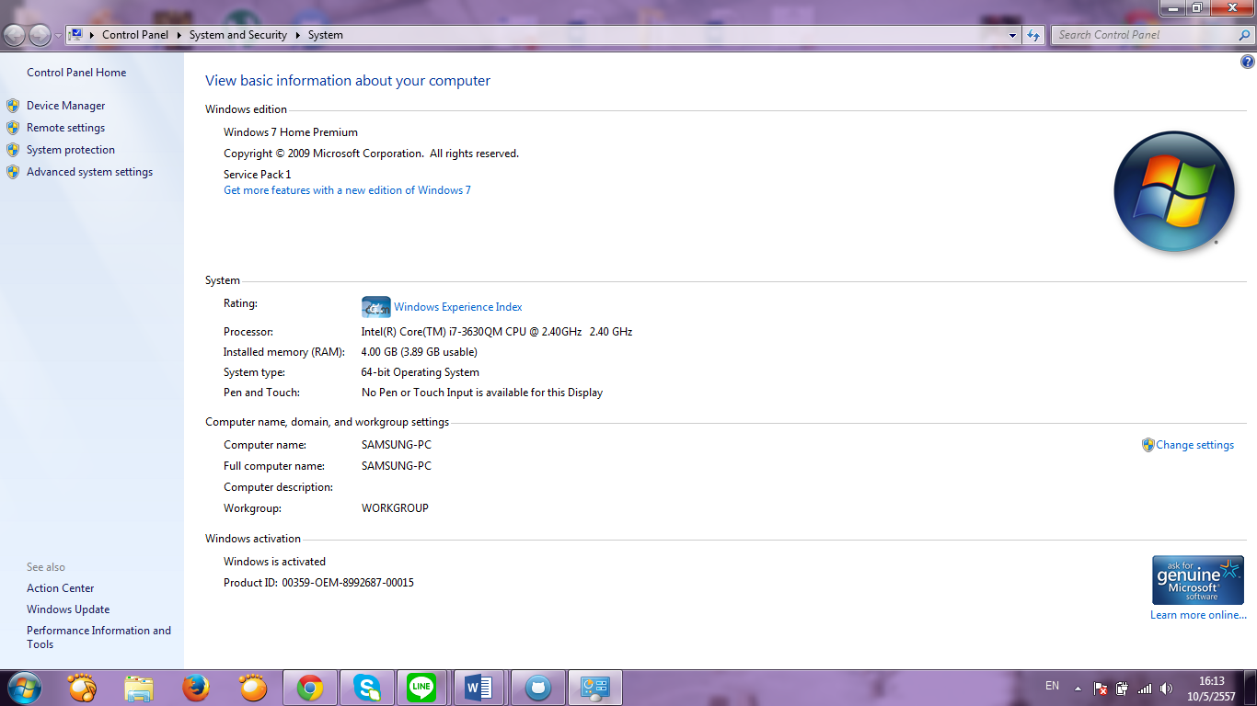

**Browser**

* Google Chrome
* Firefox

## 2.4 Design and Implementation Constraints

Internet Connection is required of use TEAMDUTY-Web application

* 1 email can be only used to register for 1 account.

# Chapter Three | User Requirement

User is a person using a generic system. There are 4 type of user, which interact to Team Duty Web application system is **Service request customer**, **freelance supply**, **Administrator and Guest**. We will be separated in each feature.

**Feature #1 - Account management system.**

**Service request customer**

E-URS – 01:*service request customer* can be Register and select type of user as *service request customer*

E-URS – 02:*service request customer* can be ConfirmRegister in their Email that they input on previously

E-URS – 03: *service request customer* can be Login to use Web Application after get user account.

E-URS – 04: The *service request customer* can manage to add or edit Picture, Name, Company name, Address, Introduce yourself, and Telephone number in profile detail as *service request customer*.

E-URS – 05: *service request customer* can be Logout from web application

E-URS – 06: *service request customer* can be ask their password form system if they forgot

**Freelance supply**

F-URS – 01:*freelance supply* can be Register and select type of user as *freelance supply*

F-URS – 02:*freelance supply* can be ConfirmRegister in their Email that they input on previously

E-URS – 03: *freelance supply* can be Login to use Web Application after get user account.

F-URS – 04:*freelance supply*can manage to Add or Edit Picture Name, Skill, Address, Introduce yourself, and Telephone number in Profile detail as *freelance supply*.

F-URS – 05: *freelance supply* can be Logout from web application

F-URS – 06: *freelance supply* can be ask their password form system if they forgot

**Feature #2 - Service request customer management system.**

**Service request customer**

E-URS – 07: The ***service request customer*** can post job and Detail as Project Name, Budget, Information, skill required and Software role categories to system that show to both of user as *service request customer* and *freelance supply*.

E-URS – 08: The ***service request customer*** can view Picture Name, Skill, and Address, Introduce yourself, and Telephone number in Profile detail of freelancer.

E-URS – 09: The ***service request customer*** can view posted job list in system.

E-URS – 10: The ***service request customer*** can view list of bidder in each project include budget & bidding detail

E-URS – 11: The ***service request customer*** can request freelancer that come to bidding their (***service request customer***) project

**Feature #3 – Search system.**

**Feature #4 – Software freelance supply management system.**

F-URS – 07: The ***freelance supply***can request job input detail of biding and budget below project information

F-URS – 08: The ***freelance supply***can view list of notification-project that posted from The ***service request customer***

**Feature #5 – Community system.**

**Service request customer**

E-URS – 12:The ***service request customer*** can view confirm project message from freelancer

E-URS – 13: The ***service request customer*** can view list of project that available.

E-URS – 14: The ***service request customer*** can uploadfile in project management process

E-URS – 15: The ***service request customer*** can downloadfile in project management process

**Freelance supply**

E-URS – 09: The ***freelance supply***can view list of project that available.

E-URS – 10: The ***freelance supply***can uploadfile in project management process

E-URS – 11: The ***freelance supply***can downloadfile in project management process

# Chapter Four | System Feature

## 4.1 Software Requirement Specification

### Feature #1 Account management system.

***Service request customer in feature#1*** Account management system

E-URS – 01:*service request customer* can be Register and select type of user as *service request customer*

E-URS – 02:*service request customer* can be ConfirmRegister in their Email that they input on previously

E-URS – 03: *service request customer* can be Login to use Web Application after get user account.

E-URS – 04: The ***service request customer*** can manage to add or edit Picture, Name, Company name, Address, Introduce yourself, Fax and Telephone number in profile detail as *service request customer*.

E-URS – 05: *service request customer* can be Logout from web application

E-URS – 06: *service request customer* can be ask their password form system if they forgot it.

**E-URS – 01:** *service request customer* can be Register and select type of user as *service request customer*

SRS 01- The system shall provide the UI which receive type of user, email, Password and ConfirmPassword.  
SRS 02 - The system shall check the email format type.

SRS 03 - The system shall check the password format. The password format must be 6-20 characters.

SRS 04 - The system shall check the matching of password and confirm password.

SRS 05 - The system shall send link and ConfirmPassword to *service request customer* email

SRS 06 - The system shall display error message “Email does not valid”

SRS 07 - The system shall display the error message “The password length must be between 6-20”

SRS 08 - The system shall display the error message “The password and confirm password

does not match”

SRS 09 - The system shall connect to database

**E-URS – 02**:*service request customer* can be ConfirmRegister in their Email that they input previously

SRS 10- The system shall provide the UI which receive ConfirmRegisterCode

SRS 11 - The system shall add new user to database using username

SRS 12 - The system shall display the error message “The ConfirmRegisterPassword is wrong”

SRS 09 - The system shall connect to database

**E-URS – 03**: *service request customer* can be Login to use Web Application after get user account.

SRS 13 - The system shall provide login interface which receive username (email) and password.

SRS 14 - The system shall validate username and password which matched with database.

SRS 15 - The system shall display the error message. “Error, the username and password is not correct”.

SRS 07 - The system can check the password format. The password format must be 6-20 characters.

SRS 09 - The system shall connect to database

**E-URS – 04**: The ***service request customer*** can manage to add or edit Picture, Name, Company name, Address, Introduce yourself, Fax and Telephone number in profile detail as *service request customer*.

SRS 16- The system shall provide user interface for receive name, address, company name, Address, Introduce yourself, Fax and Telephone number

SRS 17- The system shall provide button to browse the logo/picture.

SRS 18- The system shall allow user to edit or add the profile.

SRS 19- The system shall record profile information to database.

SRS 09- The system shall connect to database

**E-URS – 05**: *service request customer* can be Logout from web application

SRS 20- The system shall provide logout interface for logged out the system.

SRS 21- The system shall log username (email) and password out of the system.

**E-URS – 06**: *service request customer* can be ask their password form system if they forgot it.

SRS 22- The system shall provide user interface for receive Email and ComfirmPassword

SRS 02 - The system shall check the email format type.

SRS 06 - The system shall display error message “Email does not valid”

SRS 12 - The system shall display the error message “The ConfirmRegisterPassword is wrong”

SRS 09- The system shall connect to database

***freelance supply in feature#1*** Account management system  
  
F-URS – 01:*freelance supply* can be Register and select type of user as *freelance supply*

F-URS – 02:*freelance supply* can be ConfirmRegister in their Email that they input on previously

F-URS – 03: *freelance supply* can be Login to use Web Application after get user account.

F-URS – 04:*freelance supply*can manage to Add or Edit Picture Name, Skill, Address, Introduce yourself, Software Job Categories, Fax and Telephone number in Profile detail as *freelance supply*.

F-URS – 05: *freelance supply* can be Logout from web application

F-URS – 06: *freelance supply* can be ask their password form system if they forgot it.

**F-URS** – 01:*freelance supply* can be Register and select type of user as *freelance supply*

SRS 01- The system shall provide the UI which receive type of user, email, Password and ConfirmPassword.  
SRS 02 - The system shall check the email format type.

SRS 03 - The system shall check the password format. The password format must be 6-20 characters.

SRS 04 - The system shall check the matching of password and confirm password.

SRS 23 - The system shall send link and ConfirmPassword to *freelance supply* email

SRS 06 - The system shall display error message “Email does not valid”

SRS 07 - The system shall display the error message “The password length must be between 6-20”

SRS 08 - The system shall display the error message “The password and confirm password

does not match”

SRS 09 - The system shall connect to database

**F-URS – 02**:*freelance supply* can be ConfirmRegister in their Email that they input on previously

SRS 10- The system shall provide the UI which receive ConfirmRegisterCode

SRS 11 - The system shall add new user to database using username

SRS 12 - The system shall display the error message “The ConfirmRegisterPassword is wrong”

SRS 09 - The system shall connect to database

**F-URS – 03**: *freelance supply* can be Login to use Web Application after get user account.

SRS 13 - The system shall provide login interface which receive username (email) and password.

SRS 14 - The system shall validate username and password which matched with database.

SRS 15 - The system shall display the error message. “Error, the username and password is not correct”.

SRS 07 - The system can check the password format. The password format must be 6-20 characters.

SRS 09 - The system shall connect to database

**F-URS – 04**: The*freelance supply*can manage to Add or Edit Picture Name, Skill, Address, Introduce yourself, Software job categories, Fax and Telephone number in Profile detail as *freelance supply*.

SRS 24- The system shall provide user interface for receive name, address, company name, Address, Introduce yourself, Software job categories, Fax and Telephone number

SRS 17- The system shall provide button to browse the logo/picture.

SRS 18- The system shall allow user to edit or add the profile.

SRS 19- The system shall record profile information to database.

SRS 09- The system shall connect to database

**F-URS – 05**: *freelance supply* can be Logout from web application

SRS 20- The system shall provide logout interface for logged out the system.

SRS 21- The system shall log username (email) and password out of the system.

**E-URS – 06**: *freelance supply* can be ask their password form system if they forgot it.

SRS 22- The system shall provide user interface for receive Email and ComfirmPassword

SRS 02 - The system shall check the email format type.

SRS 06 - The system shall display error message “Email does not valid”

### Feature #2 Enterprise management system.

E-URS – 07: The ***service request customer*** can post job and Detail as Project Name, Budget, Information and skill required to system that show to both of user as *service request customer* and *freelance supply*.

E-URS – 08: The ***service request customer*** can view Picture Name, Skill, and Address, Introduce yourself, Software role category, Fax and Telephone number in Profile detail of freelancer.

E-URS – 09: The ***service request customer*** can view another job list in system.

E-URS – 10: The ***service request customer*** can view list of bidder in each project include budget & bidding detail

E-URS – 11: The ***service request customer*** can request freelancer that come to bidding their (***service request customer***) project

**E-URS – 07**: The ***service request customer*** can post job and Detail as Project Name, , InitialBudget , finalBudget, Information, skill required and software job category to system that show to both of user as *service request customer* and *freelance supply*.

SRS 25 - The system shall provide user interface for receive Project Name, InitialBudget , finalBudget ,Project Detail, skill required and software role category to system

SRS 26 - The system shall record job’s information to database

SRS 09 - The system shall connect to database

**E-URS – 08**: The ***service request customer*** can view Picture Name, Skill, and Address, Introduce yourself, Software role category, Fax and Telephone number in Profile detail of freelancer.

SRS 27 - The system shall display information of freelancer include Picture Name, Skill, and Address, Introduce Yourself, Software role category, Fax and Telephone number

SRS 09 - The system shall connect to database.

**E-URS – 09**: The ***service request customer*** can view posted job list in system.

SRS 28 - The system shall display job information include Project Name, Budget,

Project Detail, skill required and software role category

SRS 09 - The system shall connect to database.

**E-URS – 10**: The ***service request customer*** can view list of bidder in each project include bidId, budget, bidding detail**,** link to Freelancer profile and button to request freelancer

SRS 29 - The system shall display list of bid information below job information bidId, budget, bidding detail**,** link to Freelancer profile and button to request freelancer

SRS 09 - The system shall connect to database.

**E-URS – 11**: The ***service request customer*** can request freelancer that come to bidding their (***service request customer***) project

SRS 29 - The system shall display list of bid information below job information bidId, budget, bidding detail**,** link to Freelancer profile and button to request freelancer

SRS 30 - The system shall send message to supply freelancer that ***service request customer*** selected form bidder list.

SRS 09 - The system shall connect to database.

### Feature #3 Search system.

***Service request customer in feature#3*** Search system

**E-URS – 12**: The ***Service request customer*** can browse project by role category in left hand site of web-application.

**E-URS – 13**: The ***Service request customer*** can search project or data within web-application by input interest keyword to search UI.

**E-URS – 14**: The ***Service request customer*** can select category to search in search UI (ex Employers name)

***Freelance supply in feature#3*** Search system

**F-URS –??**: The ***freelance supply*** can browse project by role category in left hand site of web-application

**F-URS –??**: The ***freelance supply*** can search project or data within web-application by input interest keyword to search UI

### Feature #4 Software freelance supply management system.

**F-URS –??**: The ***freelance supply*** can bidding on project that ***service request customer*** posted by input Budget , Bid detail and Estimate time duration to finish project

**F-URS –??**: The ***freelance supply*** can respond request from ***service request customer*** that come to request project

**F-URS –??**: The ***freelance supply*** can view job list that posted by ***service request customer***

**F-URS –??**: The ***freelance supply*** can view job list that posted by ***service request customer***

### Feature #5 Community system.

**E-URS –??**: The ***service request customer*** can communication via web-application by using chatbox.

**F-URS –??**: The ***freelance supply*** can communication via web-application by using chatbox.

## 4.2 Use case Description & Activity Diagram

### 4.2.1 Use case Description and Activity Diagram

Use case description will be create follow the submitted user requirement in each progress. Some use cases will not have their use case description. That means the user requirements, which related to those use cases, were not submitted in any progress yet. Both use case and activity diagram will be grouped follow users of system (**service request customer**, **freelance supply**, **Guess** and **Administrator**) same as grouping of requirements.

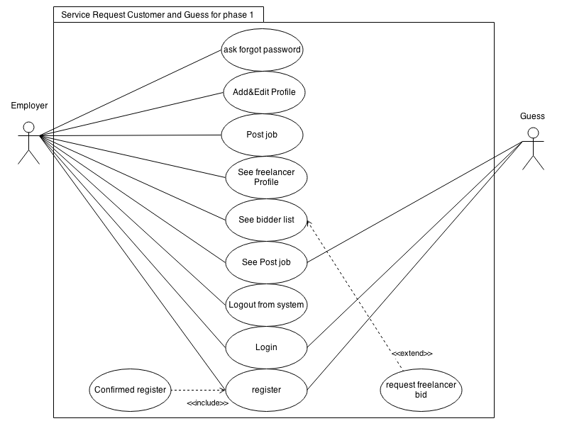***Use case of service request customer and guess for progress 1***

***Figure 4.2.1.1 Use Case Description of service request customer for progress 2***

#### E-UC – 01: Register for Service request customer

|  |  |  |
| --- | --- | --- |
| Use Case ID: | EUC-01 | |
| Use Case Name: | Register for **Service request customer** | |
| Short Description: | **Service request customer** get account for using web-application | |
| Actor: | **Service request customer** | |
| Pre-condition: | **Service request customer** does not have account | |
| Post-condition | **Service request customer** get link form E-mail that they using for register | |
| Flow of Event: | **service request customer** | **system** |
| 1. **Service request customer** selected register button in first page of Web-application |  |
|  | 2.system provide UI to select type of user input Email, Password and ConfirmPassword |
| 3. **Service request customer** Selected type of user as service request customer, input their email address, Password and Confirm Password |  |
|  | 4.System will send link to confirm register to email that user input on previously |
| 5. **Service request customer** click link on Email |  |
| Alternative Flow: | 3a. Service request customer input invalid type of email or email already existed in system   * 3a.1 system display error message * 3a.2 **Service request customer** input email address again.   3b. Service request customer input Username that already exited ,wrong confirmed code or password & confirmed password does not match   * 3b.1 system display error message * 3b.2 **Service request customer** input all of Username confirmed code, password & confirmed-password again. | |
| Exceptional: | 3. Service request customer can click back to list to go to first-page of web application | |
| Priority: | High | |

**Input**

|  |  |  |  |
| --- | --- | --- | --- |
| Name | Description | Example | Remarks |
| Memberlist | DropDownlist for input type of user receive type string | “Employer” | 1.input can be string only “Employer” cause  User need to register in type of Employer |
| Email | Only alphabet and number are allowed.  Character can be used. Need to input in type  Email | Pureman9@gmail.com | 1.Email need to be this type  [UsernameEmail@Host of Email.com] |
| Password | Only alphabet and number are allowed. | Poiu12345 |  |
| ConfirmPassword | Only alphabet and number are allowed.and need to input same Password | Poiu12345 |  |

E-AC – 01: Register for **service request customer**

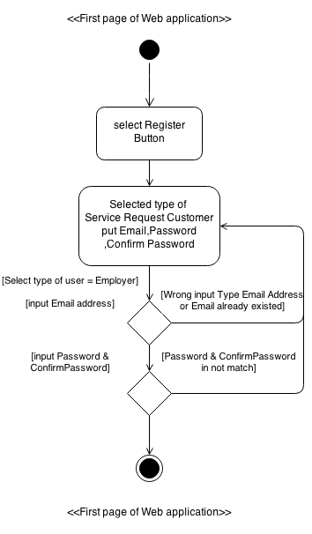

- Information Include type of User that system provided as *service request customer* and *freelance supply*, Email Address

- In Registration page they will send confirmation code to email that *service request customer* input on previously.

#### E-UC – 02: Confirm register for **Service request customer**

|  |  |  |
| --- | --- | --- |
| Use Case ID: | E-UC-02 | |
| Use Case Name: | Confirm register for **Service request customer** | |
| Short Description: | **Service request customer** confirm register in their email address | |
| Actor: | **Service request customer** | |
| Pre-condition: | **Service request customer** Register as **Service request customer** on web-application | |
| Post-condition | **Service request customer** get account to using web-application. | |
| Flow of Event: | **Service request customer** | **system** |
| 1. **Service request customer** login to their email address |  |
|  | 2.System provide confirmation Email to **Service request customer** |
| 3. **Service request customer** click open confirmation Email |  |
|  | 4.system provide ConfirmationCode and link in confirmation Email |
| 5. **Service request customer** click link |  |
|  | 6.system display confirmation page and provide UI to input Confirmation code |
| 7. **Service request customer** input confirmation code then click submit |  |
|  |  | 8. System bring **Service request customer** to main page of **Service request customer** management |
| Alternative Flow: | 7a. Service request customer input wrong confirmation   * 7a.1 system display error message * 7a.2 **Service request customer** input confirmation code again. | |
| Exceptional: | 7. Service request customer can click back to list to go to first-page of web application | |
| Priority: | High | |

|  |  |  |  |
| --- | --- | --- | --- |
| Name | Description | Example | Remarks |
| ComfirmRegisterCode | number are allowed.  Character can’t be used. | 78789098 | 1.Employer will get ConfirmRegister in Email Address. |

**Input**

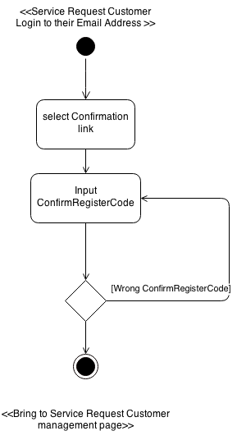E-AC – 02: Confirm register for **service request customer**

- ConfirmationRegisterCode would be automatically sent form system to email that Service Request Customer input in register page

#### E-UC – 03: Login for service request customer

|  |  |  |
| --- | --- | --- |
| Use Case ID: | EUC-03 | |
| Use Case Name: | Login for **Service request customer** | |
| Short Description: | **Service request customer** Login to using web-application system | |
| Actor: | **Service request customer** | |
| Pre-condition: | **Service request customer** Confirm register as **Service request customer** on web-application | |
| Post-condition | **Service request customer** Login to use Web-application system successfully. | |
| Flow of Event: | **Service request customer** | **system** |
| 1. **Service request customer** select Login Buttton |  |
|  | 2. Systemprovide UI to input as Username in type E-mail and password. |
| 3. **Service request customer** input Username in type E-mail and password. |  |
|  | 4.System find Username in database list |
|  | 5.System bring **Service request customer** to main page of **Service request customer** management |
| Alternative Flow: | 3a **Service request customer** input wrong type Username(not Email type) to Login or wrong password that not match with username   * 3a.1 system display error message * 3a.2 **Service request customer** input all of Username and password to login again | |
| Exceptional: | 3. Service request customer can click back to go to first-page of web application  4a. **Service request customer** account **does not exist in the database**   * 4a.1 System validation finds that the user record does not exist in the database. * 4a.2 Systems alerts the user that their record does not exist. * 4a.3 Use case ends | |
| Priority: | High | |

**Input**

|  |  |  |  |
| --- | --- | --- | --- |
| Name | Description | Example | Remarks |
| Username | Character and number are allowed.and need to input in type Email | “xxxx@cxxx.com” | 1.Email need to be this type  [UsernameofEmail@Hostof Email.com] |
| Password | Character and number are allowed. | Poiu12345 | Password need to be match with password that input at previous |

E-AC – 03: Login for **service request customer**

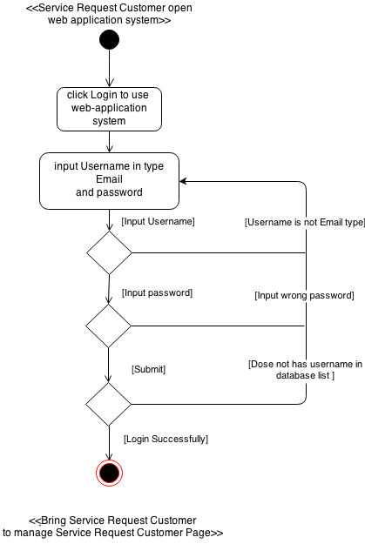

#### E-UC – 04: Add &Edit Profile for **service request customer**

|  |  |  |
| --- | --- | --- |
| Use Case ID: | EUC-04 | |
| Use Case Name: | Add Profile for **Service request customer** | |
| Short Description: | **Service request customer** Add profile to introduce about themselves to show in web application | |
| Actor: | **Service request customer** | |
| Pre-condition: | **Service request customer** Login to use Web-application system successfully. | |
| Post-condition | **Service request customer** show information about themselves to other user in web application | |
| Flow of Event: | **Service request customer** | **system** |
| 1. **Service request customer** come to **Service request customer** main page |  |
| 2. **Service request customer** click Profile manage |  |
|  | 3. Systemprovide UI to input Picture, Name, Company name, Address, Introduce yourself, Fax and Telephone number. |
| 4. **Service request customer** input Picture, Name, Company name, Address, Introduce yourself, Fax and Telephone number in to UI of system |  |
|  | 5.System retrieve Picture, Name, Company name, Address, Introduce yourself, Fax and Telephone number information save in to database |
|  | 6.System bring **Service request customer** to main page of **Service request customer** management |
| Alternative Flow: |  | |
| Exceptional: | 4. Service request customer can click back to list to go to **Service request customer** mainpage of web application | |
| Priority: | Normal | |

**Input**

Picture, Name, Company name, Address, Introduce yourself, and Telephone number.in textbox

|  |  |  |  |
| --- | --- | --- | --- |
| Name | Description | Example | Remarks |
| Name | Character and number are allowed.and need to input in type Email | “Manuchet” |  |
| Company name | Character and number are allowed. | Xcc cop |  |
| Address | Character and number are allowed. | 165/66 m4 maehear muang chiang mai 56000 |  |
| Introduce yourself | Character and number are allowed. | I have orange |  |
| Telephone number | Only number are allowed | 0862112787 |  |
| Fax | Only number are allowed | 054333323 |  |
| Picture | Should be file .png or jpg | .jpg | Size of picture must display width="75" height="75" in top right of web application page. |

E-AC – 04: Add & Edit Profile for **service request customer**

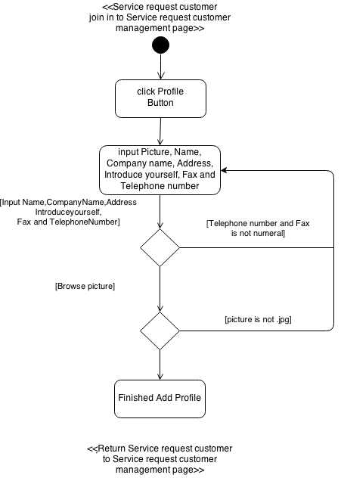

#### E-UC – 05:The **Service request customer** Logout from system

|  |  |  |
| --- | --- | --- |
| Use Case ID: | E-UC – 05 | |
| Use Case Name: | **Service request customer** Logout from system | |
| Short Description: | **Service request customer** Add profile to introduce about themselves to show in web application | |
| Actor: | **Service request customer** | |
| Pre-condition: | **Service request customer** Login to use Web-application system successfully. | |
| Post-condition | **Service request customer** Logout from system | |
| Flow of Event: | **service request customer** | **System** |
|  | 1. Systemprovide button to logout from system |
| 2.click Logout Button |  |
|  | 3.System bring first page of web application system |
| Alternative Flow: | - | |
| Exceptional: | - | |
| Priority: | Normal | |

E-AC – 05:**service request customer** Logout from system

<<Service Request Customer Login to use Web-application>>

<<Return Service Request Customer

To web-application mainpage >>

Click Logout Button

#### E-UC – 06:The **Service request customer** can be ask their password form system if they forgot

|  |  |  |
| --- | --- | --- |
| Use Case ID: | E-UC06 | |
| Use Case Name: | Login for **Service request customer** | |
| Short Description: | **Service request customer** request password that they forgot from system | |
| Actor: | **Service request customer** | |
| Pre-condition: | **-** | |
| Post-condition | **Service request customer** get password form system via Email. | |
| Flow of Event: | **Service request customer** | **system** |
| 1. **Service request customer** join to web-application |  |
| 2. **Service request customer** click login button. |  |
|  | 3. Systemprovide UI to input as Username in type E-mail and password. Are you forgot password link |
| 4. **Service request customer** click Are you forgot password link |  |
|  | 5. Systemprovide UI to input Email and ConfirmRegisterCode |
| 6. **Service request customer** input Email and ConfirmRegisterCode |  |
|  | 7.System find Email in database list |
|  | 8.System send Password to Email that they input previously |
| Alternative Flow: | 6. **Service request customer** can click back to list to go to first-page of web application  6a **Service request customer** input wrong type Username(not Email type) to Login or wrong Confirmpassword that not match with username   * 3a.1 system display error message * 3a.2 **service request customer** input all of Username and ConfirmRegisterCode to request password again. | |
| Exceptional: | 7a. **Service request customer** account **does not exist in the database**   * 7a.1 System validation finds that the user record does not exist in the database. * 7a.2 Systems alerts the user that their record does not exist. * 7a.3 Use case ends   **6. Service request customer** can’t remember their ConfirmRegisterCode | |
| Priority: | Normal | |

**Input**

|  |  |  |  |
| --- | --- | --- | --- |
| Name | Description | Example | Remarks |
| Email | Character and number are allowed.and need to input in Email type | “Pureman9@gmail.com” | 1.Email need to be this type  [UsernameEmail@Host of Email.com] |
| ComfirmRegisterCode | number are allowed.  Character can’t be used. | 78789098 | 1.Employer will get ConfirmRegisterCode in Email Address. |

Email, ComfirmRegisterCode

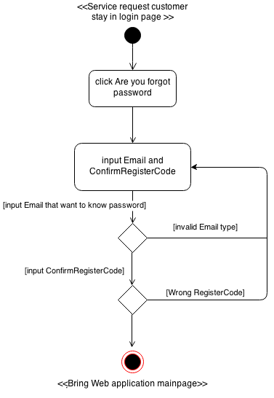E-AC – 06: **Service request customer** can be ask their password form system if they forgot

- Password would be automatically sent form system to email that Service Request Customer input in register page

#### E-UC – 07: Post Project for **service request customer**

|  |  |  |
| --- | --- | --- |
| Use Case ID: | E-UC – 06 | |
| Use Case Name: | Post Project for **Service request customer** | |
| Short Description: | **Service request customer** Post and show Project to show other user in web-application system | |
| Actor: | **Service request customer** | |
| Pre-condition: | **Service request customer** Login to use Web-application system successfully. | |
| Post-condition | - | |
| Flow of Event: | **Service request customer** | **System** |
| 1. **Service request customer** come to **Service request customer** main page |  |
| 2. **Service request customer** click post project button |  |
|  | 3. System provide UI to input Project Name, Project Description, InitialBudget ,finalBudget, skill required and Software Job Category |
| 4. **Service request customer** input Project Name, Project Description, InitialBudget ,finalBudget, skill required and Software Job Category in to UI of system |  |
|  | 5.System retrieve Project Name, Project Description, InitialBudget ,finalBudget, skill required and Software Job Category and save in to database |
|  | 6.System bring **Service request customer** to main page of **Service request customer** management |
| Alternative Flow: | 4a. **Service request customer** does not input Budget or not select any skill in list   * 4a.1 system display error message * 4a.2 **Service request customer** input all of project Budget and Select Skill required in list again   4b **Service request customer** input InitialBudget ,finalBudget not equal numeric type or finalBudget less than InitialBudget.   * 4b.1 system display error message * 4b.2 **Service request customer** input all of project Budget and Select Skill required in list again | |
| Exceptional: | 4. **Service request customer** can click back to list to go to **Service request customer** mainpage of web application | |
| Priority: | High | |

**Input**

Project Name, InitialBudget , finalBudget , Project Detail, skill required and Software role category

|  |  |  |  |
| --- | --- | --- | --- |
| Name | Description | Example | Remarks |
| Project Name | Character and number are allowed.and need to input in type Email | “Manuchet” |  |
| InitialBudget | Only number and .are allowed. | 10.00 | Value need to be two decimal places |
| finalBudget | Only number and .are allowed. | 12.00 | Value need to be two decimal places and need input value more than InitialBudget |
| Project Detail | Character and number are allowed. | “This project from XVP ccc 90 Coperation” |  |
| skill required | Skill need to be Skill that system generate | ASP.NET | Skill is type of checkbox including Java**,**Javascript**,**C**,**Cshrap**,**Cplus**,**PHP**,**Objective_C**,**Python,ASP_NET,Ruby ,SQL,Html**,**CSS**,**Android**,**XML |
| Software role category | Software role category need to be category that system generated | Web Developer | Software role category is type of |

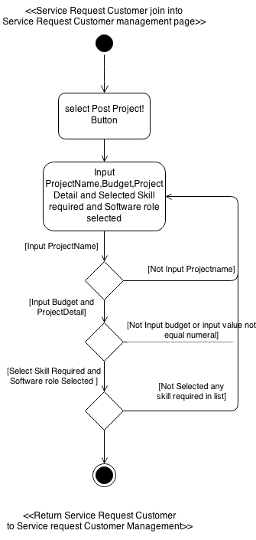E-AC – 07: Post Project for **service request customer**

- In Select skill require at least 1 box that system provide and In Software Role If Service request customer not select system will automatically input type of Software Role Equal “Web Developer”

#### E-UC – 08:The **Service request customer** can view Freelancer profile

|  |  |  |
| --- | --- | --- |
| Use Case ID: | E-UC – 08 | |
| Use Case Name: | **Service request customer** can view Freelancer profile | |
| Short Description: | **Service request customer** can view profile information of freelancer | |
| Actor: | **Service request customer** | |
| Pre-condition: | **Service request customer** Login to using web application successfully | |
| Post-condition | **-** | |
| Flow of Event: | **Service request customer** | **system** |
| 1. **Service request customer** come to **Service request customer** main page |  |
| 2. **Service request customer** click View freelancer |  |
|  | 3. Systemprovide list of freelancer that available in database. |
| 4. **Service request customer** click See more of freelancer in list. |  |
|  | 5.System will display Picture Name, Skill, Software Job Category, Address, Introduce yourself, Fax and Telephone number in Profile detail of **Supply** **Freelancer** |
| Alternative Flow: |  | |
| Exceptional: | 4. **Service request customer** can click back to list to go to **Service request customer** mainpage of web application | |
| Priority: | Normal | |

E-AC – 08: **Service request customer** can view Freelancer profile

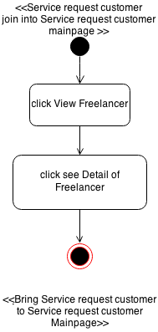

<<Bring Service Request customer to Freelancer Profile Page>>

#### E-UC – 09:The **Service request customer** can view Job list that posted to system

|  |  |  |
| --- | --- | --- |
| Use Case ID: | E-UC – 09 | |
| Use Case Name: | **Service request customer** can view Job list that posted to system | |
| Short Description: | **Service request customer** can view Job list within system | |
| Actor: | **Service request customer** | |
| Pre-condition: | **Service request customer** Login to using web application successfully | |
| Post-condition | - | |
| Flow of Event: | **Service request customer** | **system** |
| 1. **Service request customer** come to **Service request customer** main page |  |
| 2. **Service request customer** click job title |  |
|  | 3. System provide Datetopost ,Titlenamelist of job that available in database include InitialBudget, finalBudget and Software role Category |
| 4. **Service request customer** click “See more” of Job that **Service request customer** want to see |  |
|  | 5.System will display Post Date,Software Job Category, Title,Description, InitialBudget, finalBudget, Skill required and Other skill |
| Alternative Flow: |  | |
| Exceptional: | 4. Service request customer can click back to list to go to **Service request customer** mainpage of web application | |
| Priority: | Normal | |

E-AC – 09: **Service request customer** can view other Job list within system

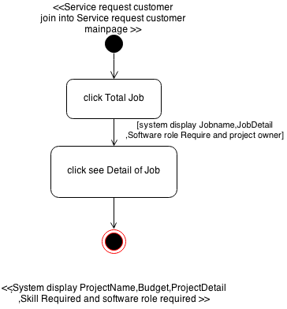

#### E-UC – 10:The **Service request customer** can view list of bidder

|  |  |  |
| --- | --- | --- |
| Use Case ID: | E-UC – 10 | |
| Use Case Name: | **Service request customer** can view list of bidder | |
| Short Description: | **Service request customer** can view list of bidder in each project include budget & bidding detail | |
| Actor: | **Service request customer** | |
| Pre-condition: | **Service request customer** Login to using web application successfully | |
| Post-condition | **-** | |
| Flow of Event: | **Service request customer** | **system** |
| 1. **Service request customer** come to **Service request customer** main page |  |
| 2. **Service request customer** click job title |  |
|  | 3. System provide Datetopost ,Titlenamelist of job that available in database include InitialBudget, finalBudget and Software role Category |
| 4. **Service request customer** click detail of Job that they want to see |  |
|  | 5.System will display FreelancePicture,BidId freelancerName,BidderDetail and Budget in bidder list below job information |
| Alternative Flow: |  | |
| Exceptional: | 4. Service request customer can click back to list to go to **Service request customer** mainpage of web application | |
| Priority: | Normal | |

E-AC-10: The **service request customer** can view list of bidder

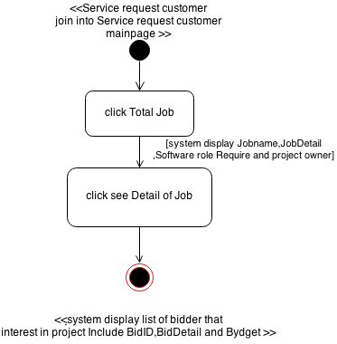

|  |  |  |
| --- | --- | --- |
| Use Case ID: | E-UC – 11 | |
| Use Case Name: | **Service request customer** can request freelancer that come to bidding their (***service request customer***) project | |
| Short Description: | **Service request customer** can request Freelancer in bidder list at their own project | |
| Actor: | **Service request customer** | |
| Pre-condition: | **Service request customer** Login to using web application successfully | |
| Post-condition | **-** | |
| Flow of Event: | **Service request customer** | **system** |
| 1. **Service request customer** come to **Service request customer** main page |  |
| 2. **Service request customer** click job title |  |
|  | 3. System provide Datetopost ,Titlenamelist of job that available in database include InitialBudget, finalBudget and Software role Category |
| 4. **Service request customer** click detail of Job that they want to see |  |
|  | 5.System will display FreelancePicture,BidId freelancerName,BidderDetail and Budget in bidder list below job information |
|  | 6. **Service request customer** click request |  |
| Alternative Flow: |  | |
| Exceptional: | 4. Service request customer can click back to list to go to **Service request customer** mainpage of web application | |
| Priority: | Normal | |

#### E-UC – 11: The **Service request customer** can request freelancer that come to bidding their (***service request customer***) project

E-AC-11: The ***service request customer*** can request freelancer that come to bidding their (***service request customer***) project

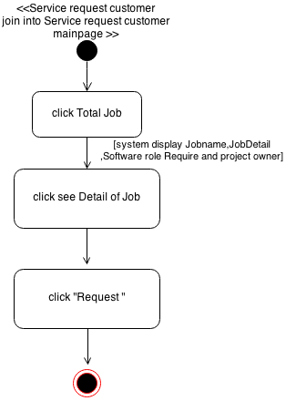

#### E-UC – 12: The ***Service request customer*** can browse project by Software-role category in left hand site of web-application.

|  |  |  |
| --- | --- | --- |
| Use Case ID: | E-UC – 12 | |
| Use Case Name: | **Service request customer** can browse project by Software-role category in left hand site of web-application. | |
| Short Description: | **Service request customer** can search project by Software-role category in left hand site of web-application. | |
| Actor: | **Service request customer** | |
| Pre-condition: | **Service request customer** Login to using web application successfully | |
| Post-condition |  | |
| Flow of Event: | **Service request customer** | **system** |
| 1. **Service request customer** come to **Service request customer** main page |  |
| 2. **Service request customer** can view list of Software-role category  in left-hand-side of **Service request customer** main page |  |
| 3. **Service request customer** select one of list in Software-role category  in left-hand-side. |  |
|  | 4. System will display project list page that match with Software-role category that  **Service request customer** on previously |
| Alternative Flow: |  | |
| Exceptional: | 4. Service request customer can click back to list to go to **Service request customer** mainpage of web application | |
| Priority: | Normal | |

#### E-AC – 12: The ***Service request customer*** can browse project by Software-role category in left hand site of web-application.

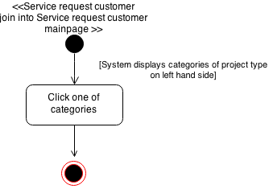

#### E-UC – 13: The ***Service request customer*** can search project or data within web-application by input interest keyword to search UI.

|  |  |  |
| --- | --- | --- |
| Use Case ID: | E-UC – 13 | |
| Use Case Name: | **Service request customer** can search project or data within web-application by input interest keyword to search UI. | |
| Short Description: | **Service request customer** can search project or data within web-application by input interest keyword to search UI. | |
| Actor: | **Service request customer** | |
| Pre-condition: | **Service request customer** Login to using web application successfully | |
| Post-condition |  | |
| Flow of Event: | **Service request customer** | **system** |
| 1. **Service request customer** come to **Service request customer** main page |  |
| 2. **Service request customer** input  interest keyword to search UI then click search. |  |
|  | 3. System will display list of data or project that concerned with interest keyword. |
| Alternative Flow: | 2a.If  **Service request customer** interest keyword that not concerned with any keyword in Webapplicaion   * System will display error message. * **Service request customer** need to input interest keyword again. | |
| Exceptional: | 4. Service request customer can click back to list to go to **Service request customer** mainpage of web application | |
| Priority: | Normal | |

#### (Edit)E-UC – 14: The User can select category to search in search UI

***Use case of freelance supply for progress 1***

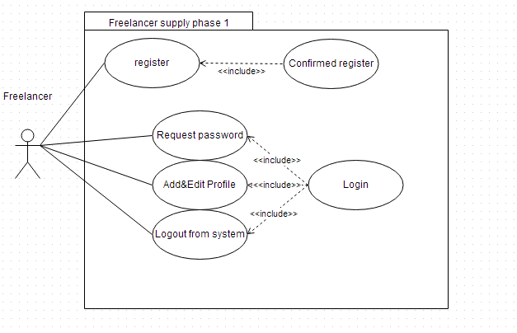

***Figure 4.2.1.2 Use Case Description of freelance supply for progress 1***

#### F-UC – 01: Register for ***Freelance supply***

|  |  |  |
| --- | --- | --- |
| Use Case ID: | F-UC-01 | |
| Use Case Name: | Register for **Freelance supply** | |
| Short Description: | **Freelance supply** get account for using web-application | |
| Actor: | **Freelance supply** | |
| Pre-condition: | **Freelance supply** does not have account | |
| Post-condition | **Freelance supply** get link form E-mail that they using for register | |
| Flow of Event: | **Freelance supply** | **system** |
| 1. **Freelance supply** selected register button in first page of Web-application |  |
|  | 2.system provide UI to input Email, select type of user password and ConfirmPassword |
| 3. **Freelance supply** Selected type of user as freelancer, input their email address password and ConfirmPassword. |  |
|  | 4.System will send link to confirm register to email that user input on previously |
| 5. **Freelance supply** click link on Email |  |
| Alternative Flow: | 3. **Freelance supply** can click back to list to go to first-page of web application  3a. **Freelance supply** input invalid type of email or email already existed in system   * 3a.1 system display error message * 3a.2 **Freelance supply** input email address again.   3b. **Freelance supply** input wrong confirmed code or password & confirmed password does not match   * 3b.1 system display error message * 3b.2 **Freelance supply** input all of Email, password & confirmed-password again. | |
| Exceptional: |  | |
| Priority: | High | |

**Input**

|  |  |  |  |
| --- | --- | --- | --- |
| Name | Description | Example | Remarks |
| Memberlist | DropDownlist for input type of user receive type string | “Employer”,”Freelancer” | 1.input can be string only “Freelancer” cause  User need to register in type of Freelancer |
| Email | Only alphabet and number are allowed.  Character can be used. Need to input in type  Email | Pureman8@hotmail.com | 1.Email need to be this type  [UsernameofEmail.Hostof Email.com] |
| Password | Only alphabet and number are allowed. | Poiu123459 |  |
| ConfirmPassword | Only alphabet and number are allowed.and need to input same Password | Poiu123459 |  |

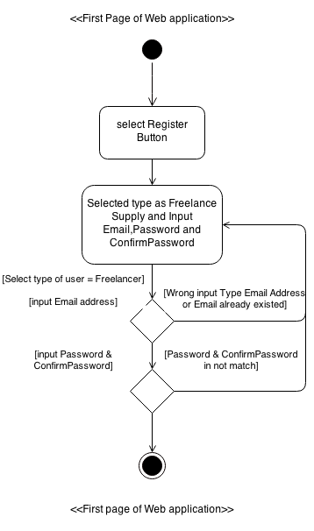F-AC – 01: Register for **freelance supply**

- Information Include type of User that system provided as *service request customer* and *freelance supply*, Email Address

- In Registration page they will send confirmation code to email that *Freelancer supply* input on previously.

#### F-UC – 02: Confirm register for ***Freelance supply***

|  |  |  |
| --- | --- | --- |
| Use Case ID: | F-UC-02 | |
| Use Case Name: | Confirm register for **Freelance supply** | |
| Short Description: | **Freelance supply** confirm register in their email address | |
| Actor: | **Freelance supply** | |
| Pre-condition: | **Freelance supply** Register as **freelance supply** on web-application | |
| Post-condition | **Freelance supply** get account to using web-application. | |
| Flow of Event: | **Freelance supply** | **system** |
| 1. **Freelance supply** login to their email address |  |
|  | 2.System provide confirmation Email to **Freelance supply** |
| 3. **Freelance supply** click open confirmation Email |  |
|  | 4.system provide ConfirmationCode and link in confirmation Email |
| 5. **Freelance supply** click link |  |
|  | 6.system display confirmation page and provide UI to input Confirmation code |
| 7. **Freelance supply** input confirmation code then click submit |  |
| Alternative Flow: | 4a. **Freelance supply** input wrong confirmed code does not match   * 4a.1 system display error message * 4a.2 **Freelance supply** confirmed code again. | |
| Exceptional: | 3. **Freelance supply** can click back to list to go to first-page of web application | |
| Priority: | High | |

**Input**

|  |  |  |  |
| --- | --- | --- | --- |
| Name | Description | Example | Remarks |
| ComfirmRegisterCode | number are allowed.  Character can’t be used. | 78789098 | 1.Freelancer will get ConfirmRegister in Email Address. |

F-AC – 02: Confirm register for **freelance supply**

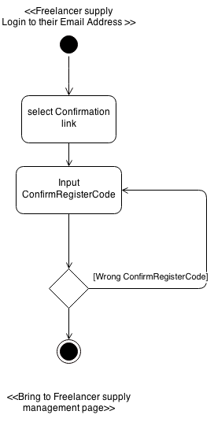

#### F-UC – 03: Login for ***Freelance supply***

|  |  |  |
| --- | --- | --- |
| Use Case ID: | F-UC-03 | |
| Use Case Name: | Login for **Freelance supply** | |
| Short Description: | **Freelance supply** Login to using web-application system | |
| Actor: | **Freelance supply** | |
| Pre-condition: | **Freelance supply** Confirm register as **freelance supply** on web-application | |
| Post-condition | **Freelance supply** Login to use Web-application system successfully. | |
| Flow of Event: | **freelance supply** | **system** |
| 1. **Freelance supply** join to web-application |  |
|  | 2. Systemprovide UI to input as Username in type E-mail and password. |
| 3. **Freelance supply** input Username in type E-mail and password. |  |
|  | 4.System find Username in database list |
|  | 5.System bring **Freelance supply** to main page of **Freelance supply** management |
| Alternative Flow: | 3. Service request customer can click back to list to go to first-page of web application  3a **Freelance supply** input wrong type Username(not Email type) to Login or wrong password that not match with username   * 3a.1 system display error message * 3a.2 **freelance supply** input all of Username and password to login again. | |
| Exceptional: | 4a. **Freelance supply** account **does not exist in the database**   * 4a.1 System validation finds that the user record does not exist in the database. * 4a.2 Systems alerts the user that their record does not exist. * 4a.3 Use case ends | |
| Priority: | High | |

**Input**

|  |  |  |  |
| --- | --- | --- | --- |
| Name | Description | Example | Remarks |
| Username | Character and number are allowed.and need to input in type Email | “xxxx@cxxx.com” | 1.Email need to be this type  [UsernameofEmail.Hostof Email.com] |
| Password | Character and number are allowed. | Poiu12345 | Password need to be match with password that input at previous |

E-AC – 03: Login for **freelance supply**

#### F-UC – 04: Add &Edit Profile for ***Freelance supply***

|  |  |  |
| --- | --- | --- |
| Use Case ID: | F-UC-04 | |
| Use Case Name: | Add Profile for **Freelance supply** | |
| Short Description: | **Freelance supply** Add profile to introduce about themselves to show in web application | |
| Actor: | **Freelance supply** | |
| Pre-condition: | **Freelance supply** Login to use Web-application system successfully. | |
| Post-condition | **Freelance supply** show information about themselves to other user in web application | |
| Flow of Event: | **freelance supply** | **system** |
| 1. **Freelance supply** come to **Freelance supply** main page |  |
| 2. **Freelance supply** click Profile manage |  |
|  | 3. Systemprovide UI to input Picture, Name, Company name, Address, Introduce yourself, and Telephone number. |
| 4. **Freelance supply** input Picture, Name, Company name, Address, Introduce yourself, and Telephone number in to UI of system |  |
|  | 5.System retrieve Picture, Name, Company name, Address, Introduce yourself, and Telephone number information save in to database |
|  | 6.System bring **freelance supply** to main page **freelance supply** management |
| Alternative Flow: | 4. **freelance supply** can click back to list to go to **freelance supply** mainpage of web application | |
| Exceptional: | - | |
| Priority: | Normal | |

**Input**

Name, Company name, Address, Introduce yourself, and Telephone number. And Browse Picture to input to database

|  |  |  |  |
| --- | --- | --- | --- |
| Name | Description | Example | Remarks |
| Name | Character and number are allowed.and need to input in type Email | “Manuchet” |  |
| Address | Character and number are allowed. | 165/66 m4 maehear muang chiang mai 56000 |  |
| Introduce yourself | Character and number are allowed. | I have orange |  |
| Telephone number | Only number are allowed | 086-211-2787 |  |
| Picture | Should be file .png or jpg | .jpg | Size of picture width="75" height="75" |

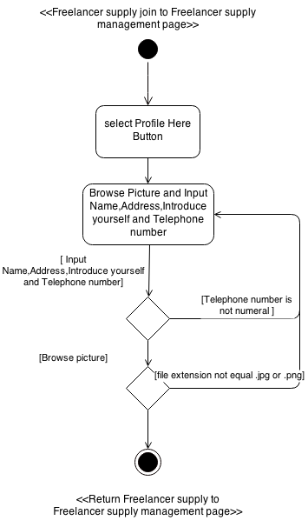F-AC – 04: Add&Edit Profile for **freelance supply**

#### F-UC – 05: The ***Freelance supply*** Logout from system

|  |  |  |
| --- | --- | --- |
| Use Case ID: | F-UC – 05 | |
| Use Case Name: | **Freelance supply** Logout from system | |
| Short Description: | **Freelance supply** Add profile to introduce about themselves to show in web application | |
| Actor: | **Freelance supply** | |
| Pre-condition: | **Freelance supply** Login to use Web-application system successfully. | |
| Post-condition | **Freelance supply** Logout from system | |
| Flow of Event: | **Freelance supply** | **system** |
|  | 1. Systemprovide button to logout from system |
| 2.click Logout Button |  |
|  | 3.System bring **freelance supply** first page of web application system |
| Alternative Flow: | - | |
| Exceptional: | - | |
| Priority: | Normal | |

F-AC – 05: **freelance supply** Logout from system

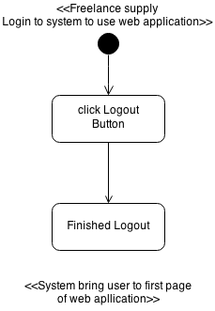

#### F-UC – 06: The ***Freelance supply*** can be ask their password form system if they forgot

|  |  |  |
| --- | --- | --- |
| Use Case ID: | F-UC06 | |
| Use Case Name: | Login for **Freelance supply** | |
| Short Description: | **Freelance supply** request password that they forgot from system | |
| Actor: | **Freelance supply** | |
| Pre-condition: | **-** | |
| Post-condition | **Freelance supply** get password form system via Email. | |
| Flow of Event: | **Freelance supply** | **system** |
| 1. **Freelance supply** join to web-application |  |
| 2. **Freelance supply** click login button. |  |
|  | 3. Systemprovide UI to input as Username in type E-mail and password. Are you forgot password link |
| 4. **Freelance supply** click Are you forgot password link |  |
|  | 5. Systemprovide UI to input Email and ConfirmationCode |
| 6. **Freelance supply** input Email and ConfirmationCode |  |
|  | 7.System find Email in database list |
|  | 8.System send Password to Email that they input previously |
| Alternative Flow: | 6. **Freelance supply** can click back to list to go to first-page of web application  6a **Freelance supply** input wrong type Username(not Email type) to Login or wrong ConfirmationCode that not match with username   * 3a.1 system display error message * 3a.2 **Freelance supply** input all of Username and ConfirmationCode to login again. | |
| Exceptional: | 7a. **Freelance supply** account **does not exist in the database**   * 4a.1 System validation finds that the user record does not exist in the database. * 4a.2 Systems alerts the user that their record does not exist. * 4a.3 Use case ends   **6 Freelance supply** can’t remember their ConfirmRegisterCode | |
| Priority: | Normal | |

**Input**

Email, ComfirmRegisterCode

|  |  |  |  |
| --- | --- | --- | --- |
| Name | Description | Example | Remarks |
| Email | Character and number are allowed.and need to input in Email type | “Pureman9@gmail.com” | 1.Email need to be this type  [UsernameEmail@Host of Email.com] |
| ComfirmRegisterCode | number are allowed.  Character can’t be used. | 78789098 | 1.Employer will get ConfirmRegisterCode in Email Address. |

F-AC – 06:*freelance supply* can be ask their password form system if they forgot

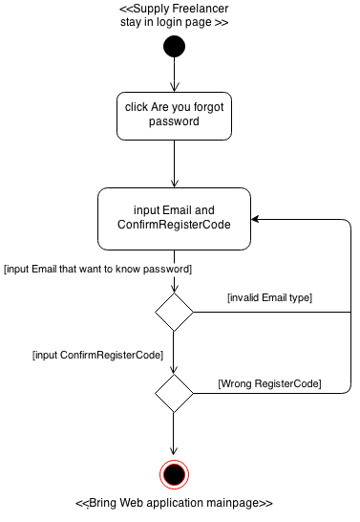

#### F-UC – 07: The ***freelance supply*** can browse project by role category in left hand site of web-application

|  |  |  |
| --- | --- | --- |
| Use Case ID: | F-UC - 07 | |
| Use Case Name: | **Freelance supply** browse project by role category | |
| Short Description: | **Freelance supply** browse project by role category in left hand site of the web-application | |
| Actor: | **Freelance supply** | |
| Pre-condition: | **-** | |
| Post-condition | **Freelance supply** get password form system via Email. | |
| Flow of Event: | **Freelance supply** | **system** |
| 1. **Freelance supply** join to web-application |  |
| 2. **Freelance supply** click login button. |  |
|  | 3. Systemprovide UI to input as Username in type E-mail and password. Are you forgot password link |
| 4. **Freelance supply** click Are you forgot password link |  |
|  | 5. Systemprovide UI to input Email and ConfirmationCode |
| 6. **Freelance supply** input Email and ConfirmationCode |  |
|  | 7.System find Email in database list |
|  | 8.System send Password to Email that they input previously |
| Alternative Flow: | 6. **Freelance supply** can click back to list to go to first-page of web application  6a **Freelance supply** input wrong type Username(not Email type) to Login or wrong ConfirmationCode that not match with username   * 3a.1 system display error message * 3a.2 **Freelance supply** input all of Username and ConfirmationCode to login again | |
| Exceptional: | 7a. **Freelance supply** account **does not exist in the database**   * 4a.1 System validation finds that the user record does not exist in the database. * 4a.2 Systems alerts the user that their record does not exist. * 4a.3 Use case ends   **6 Freelance supply** can’t remember their ConfirmRegisterCode | |
| Priority: | Normal | |

## 4.3 Quality Requirement

**Product operation factors**

* **Correctness** - The software product should able to provide more than 90% correctness of data from user traditional request.
* **Reliability** - The software should able to handle more than 90% of traditional activity with less than 10% of software’s failure.

**Product revision factors**

* **Testability** - The software should able to be tested 100% of it defined routine and functionality.

**Product transition factors**

* **Reusability** - More than 20% part of finished software product should able to be reused in future development.